Lambda Task
Navigate to lambda services
Creating a demo_lambda_function
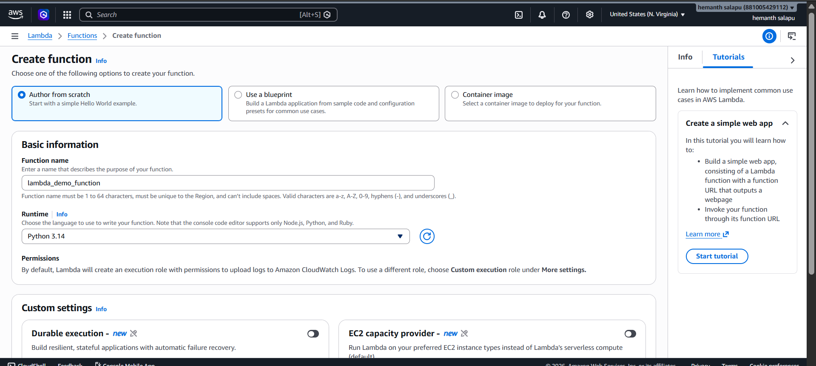 lambda_function Created
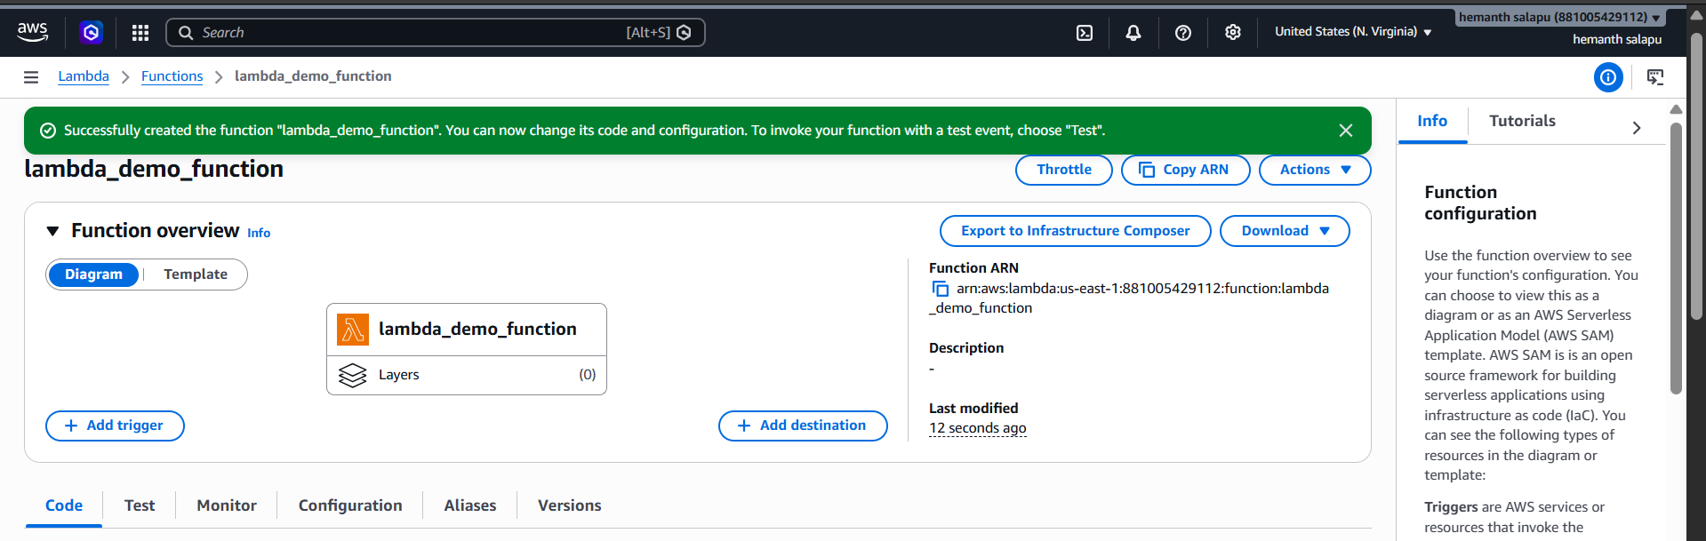
Deploy the function and create a test event and execute lambda
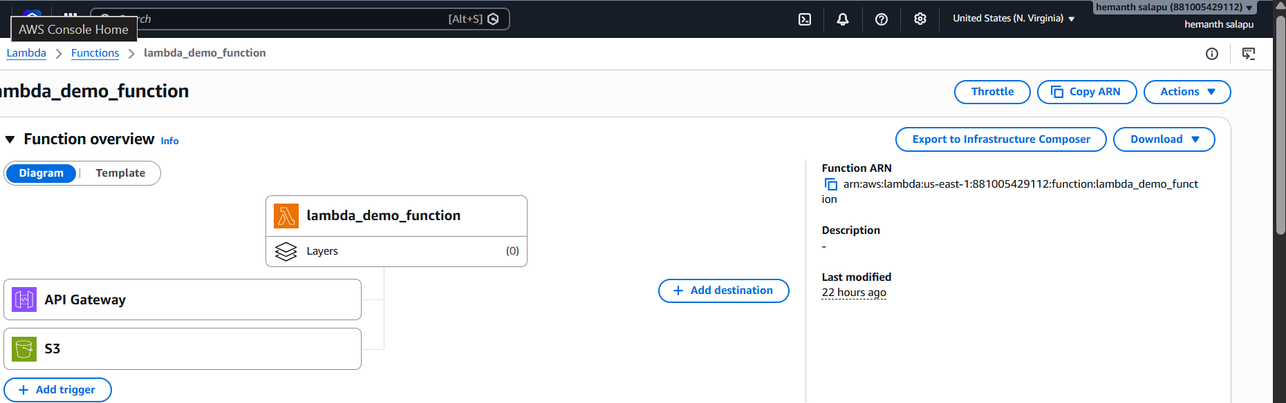
We can see the triggers of the s3 details
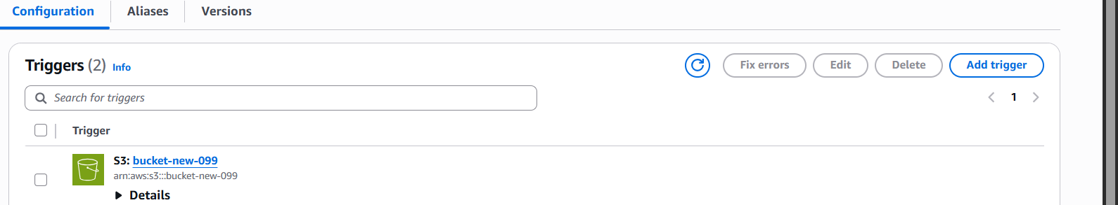
Upload the new file in s3 bucket to check in watch logs
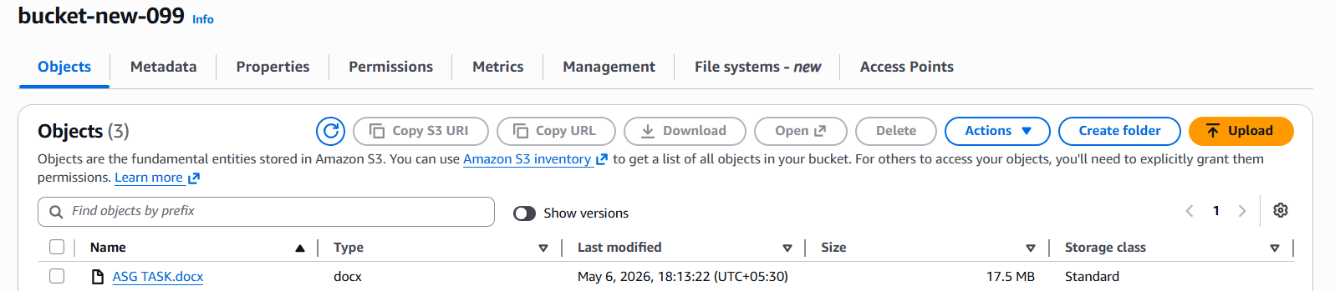
We can check in Cloudwatch log files
